Close Contact Protocol
Quarantine vs. “Test and Stay”
If your student is exposed to COVID-19 and is a close contact, your student will need to be monitored and tested. Below are the two options, which impact your student’s learning environment differently:

“Test and Stay” Protocol
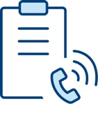 |  | Close Contacts Notified  Anyone who considered “close contact” based on exposure.
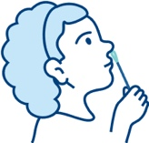 |  | “Test and Stay”  anyone without symptoms: rapid test daily for 5 days and stay in school to learn
 | 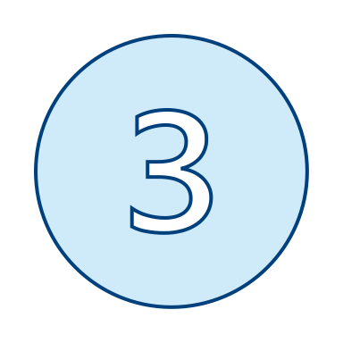 | Return to Routine COVID Safety Checks  After 5 days

Quarantine Protocol
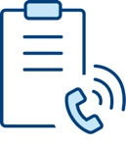 |  | Close Contacts Notified  Anyone who considered “close contact” based on exposure.
Learn Remotely
10 days
Return to In-School Learning
No symptoms

